

Use Case Specification: eCL Supervisor Review
For
eCoaching Log

Change History Log

Date | Version | Description | Author
01/12/2015 | 1.0 | Initial Document | Doug Stearns

Table of Contents

1. Brief Description 5
2. Participating Actors 5
2.1 Primary 5
2.2 Secondary 5
3. Basic Flow of Events 6
3.1 Access eCoaching Log website My Dashboard page. 6
3.2 Select eCoaching Log from My Pending eCoaching Logs section with a Pending Supervisor Review status (supervisor of CSR or LSA). 6
3.3 Read and review information on the review page. 6
3.4 Enter or select date of coaching (required entry). 6
3.5 Enter details from coaching session including action plans developed (required entry; free form text up to 3000 characters). 6
3.6 Submit the review for eCoaching Log to be reviewed by Employee. 6
4. Alternative Flows 7
4.1 Select Pending Quality Lead Review coaching log. [Step 3.2] 7
4.2 Select Pending Acknowledgement coaching log. [Step 3.2] 7
4.3 Select Pending Manager Review coaching log. [Step 3.2] 7
4.4 Select Pending Supervisor Review coaching log – coaching required. [Step 3.2] 7
4.5 Select Pending Supervisor Review coaching log – coaching not required. [Step 4.4.3] 8
4.6 Select Pending Manager Review coaching log – coaching required. [Step 3.2] 8
4.7 Select Pending Manager Review coaching log – coaching not required. [Step 4.4.3] 8
4.8 Select Completed coaching log. [Step 3.2] 9
5. Preconditions 9
5.1 eCoaching Log website available. 9
5.2 eCoaching Log database available. 9
5.3 eCoaching Log database populated with correct and current hierarchy information for Employee, Supervisor, Manager. 9
5.4 eCoaching Log Submissions and Notifications have taken place. 9
5.5 eCoaching Log Dashboard is available. 9
6. Postconditions 9
6.1 Appropriate review information is written to database. 9
7. Assumptions and Dependencies 9
7.1 Access to Supervisor Review will be limited to those who are the immediate supervisors of recipients of coaching logs. 9
8. Business Rules 10
8.1 none 10
9. Technical Requirements 10
9.1 none 10
10. Activity Diagrams 11

Table of Figures
Figure 1 – eCL Supervisor Review 9

Brief Description
eCoaching Logs Supervisor Review for those who are supervisors of coaching log recipients. Supervisors review logs and provide coaching to employees. Note: the supervisors can be supervisors of CSRs, other supervisors, Quality Specialists or LSAs.

Participating Actors

Primary

Supervisors (review eCoaching Logs assigned to Supervisors)

Secondary

None

Basic Flow of Events

Access eCoaching Log website My Dashboard page.

Select eCoaching Log from My Pending eCoaching Logs section with a Pending Supervisor Review status (supervisor of CSR or LSA).

Read and review information on the review page.

Enter or select date of coaching (required entry).

Enter details from coaching session including action plans developed (required entry; free form text up to 3000 characters).

Submit the review for eCoaching Log to be reviewed by Employee.

Alternative Flows

Select Pending Quality Lead Review coaching log. [Step 3.2]

Select eCoaching Log from My Pending eCoaching Logs section with Pending Quality Lead Review status (supervisor of quality specialist).

Read and review information on the review page.

Enter or select date of coaching (required entry).

Enter coaching notes include any action plans (free form text up to 3000 characters) (required entry).

Continue with Step 3.6 above.

Select Pending Acknowledgement coaching log. [Step 3.2]

Select eCoaching Log from My Pending eCoaching Logs section with Pending Acknowledgement status (supervisor of CSR).

Read and review information on the review page.

Check the box to acknowledge the coaching opportunity (required entry).

Continue with Step 3.6 above.

Select Pending Manager Review coaching log. [Step 3.2]

Select eCoaching Log from My Pending eCoaching Logs section with Pending Manager Review status (supervisor of a supervisor).

Read and review information on the review page.

Enter or select date of coaching (required entry).

Enter details of coaching session including action plans (free form text up to 3000 characters) (required entry).

Continue with Step 3.6 above.

Select Pending Supervisor Review coaching log – coaching required. [Step 3.2]

Select eCoaching Log from My Pending eCoaching Logs section with Pending Supervisor Review status (supervisor of CSR) when coaching log for ETS OAE or OAS and Research Required.

Read and review information on the review page.

Confirm if research indicates the log does require coaching. Select Yes does require coaching (required entry).

Possible options are:
Yes
No

Enter or select date of coaching (required entry).

Enter reason / explanation / justification why coaching is required (free form text up to 3000 characters) (required entry).

Continue with Step 3.6 above.

Select Pending Supervisor Review coaching log – coaching not required. [Step 4.4.3]

Confirm if research indicates the log does require coaching. Select No does not require coaching (required entry).

Possible options are:
Yes
No

Enter or select date of review (required entry).

Select main reason not coachable (required entry).

Possible options are:
Other

Enter reason / explanation / justification why coaching is not required (free form text up to 3000 characters) (required entry).

Continue with Step 3.6 above.

Select Pending Manager Review coaching log – coaching required. [Step 3.2]

Select eCoaching Log from My Pending eCoaching Logs section with Pending Manager Review status (supervisor of supervisor) when coaching log for ETS OAE or OAS and Research Required.

Read and review information on the review page.

Confirm if research indicates the log does require coaching. Select Yes does require coaching (required entry).

Possible options are:
Yes
No

Enter or select date of coaching (required entry).

Enter reason / explanation / justification why coaching is required (free form text up to 3000 characters) (required entry).

Continue with Step 3.6 above.

Select Pending Manager Review coaching log – coaching not required. [Step 4.4.3]

Confirm if research indicates the log does require coaching. Select No does not require coaching (required entry).

Possible options are:
Yes
No

Enter or select date of review (required entry).

Select main reason not coachable (required entry).

Possible options are:
Other

Enter reason / explanation / justification why coaching is not required (free form text up to 3000 characters) (required entry).

Continue with Step 3.6 above.

Select Completed coaching log. [Step 3.2]

Select eCoaching Log with Complete status

Read and review information on the review page.

Close review page.

Preconditions

eCoaching Log website available.

eCoaching Log database available.

eCoaching Log database populated with correct and current hierarchy information for Employee, Supervisor, Manager.

eCoaching Log Submissions and Notifications have taken place.

eCoaching Log Dashboard is available.

Postconditions

Appropriate review information is written to database.

Assumptions and Dependencies

Access to Supervisor Review will be limited to those who are the immediate supervisors of recipients of coaching logs.
Module | Supervisor | Job Codes
CSR | Supervisor | WACS40
Supervisor | Manager | WACS50
Quality | Quality Lead | WACQ03, WACQ13, WACQ40
LSA | LSA | WMPR40

Business Rules

none

Technical Requirements

none

Activity Diagrams
Below is the activity diagram for the use case that provides a visual depiction of the flow of events.

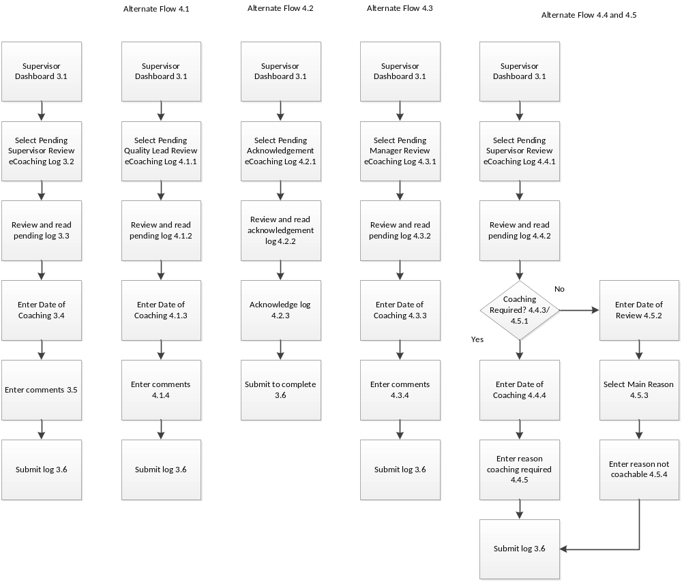

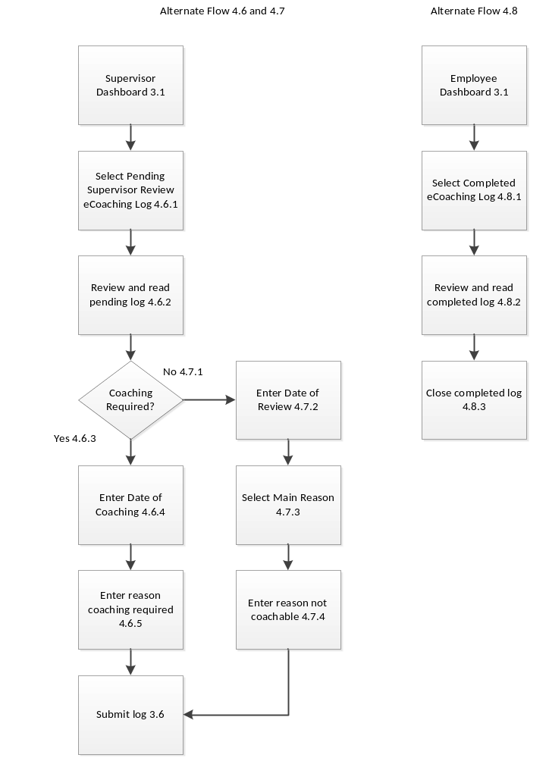
Figure 1 – eCL Supervisor Review

